**Create the "Simple Image Resizer Tool"**

* **JIRA**

**Steps to Create a Project and Setup in Jira**

1. **Sign Up and Log In**

* Go to Atlassian Jira.
* Create an account or log in with your Atlassian credentials.
* After login, Jira will guide you through project setup.

### 2. ****Choose Types of Work****

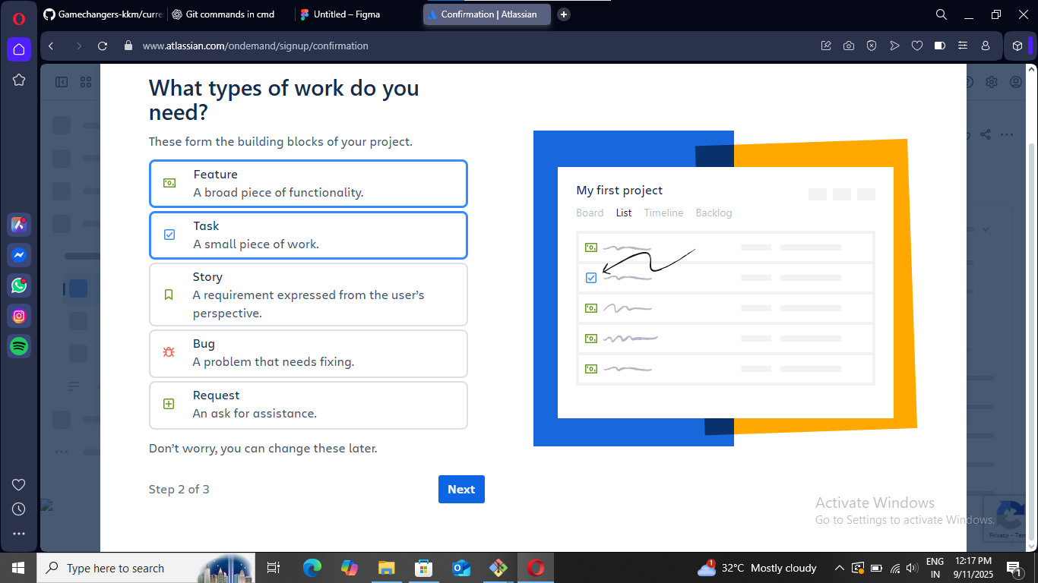

* Jira asks: “What types of work do you need?”
* Options include:
  + **Feature** – A broad piece of functionality.
  + **Task** – A small piece of work.
  + **Story** – A requirement from the user’s perspective.
  + **Bug** – A problem that needs fixing.
  + **Request** – An ask for assistance.
* Select the ones suitable for your project. (In your case, **Task** was chosen).
* Click **Next** to proceed.

### ****Set Work Tracking Status****

### C:\wee\jira\2.png

* Jira asks: “How do you track work?”
* Default workflow statuses are:
  + **To Do** – Work not yet started.
  + **In Progress** – Work currently being done.
  + **In Review** – Work waiting for review.
  + **Done** – Completed work.
* You can add/remove statuses if needed.
* Click **Finish** to complete setup.

### 4. ****View Your Dashboard****

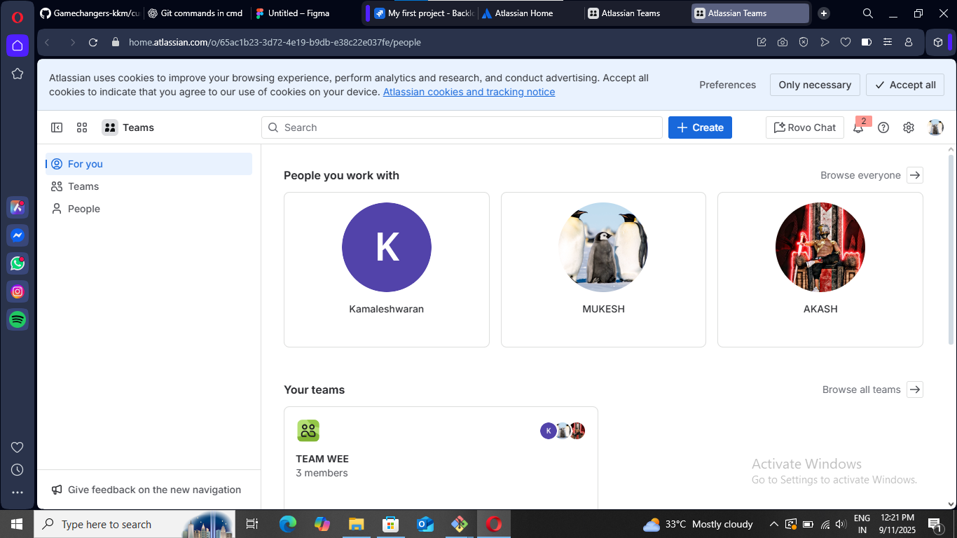

* You are redirected to the **Atlassian Home dashboard**.
* Here, you can see:
  + My **profile** ( Kamaleshwaran).
  + Team members (Mukesh, Akash, etc.).
  + Your teams (e.g., **TEAM WEE – 3 members**).
* From here, you can start creating issues, assigning tasks, and collaborating with your team.